Wolverine Community Advisory Group
Full CAG Meeting
Online using Zoom

Thursday, September 17, 2020 6pm

Attendees: Tammy Bergstrom, AJ Birkbeck, Carol Butts, Jenny Carney, Lance Climie, Linda Goossen, Elaine Isely, Tom Konecsni, Gail Mancewicz, Grant Medich, Jonathan Miner, Wendy Ogilvie, Ivan Phillips, Jim Powell, Rick Rediske, Tom Sapkowski, Mike Shibler, Rick Solle, Cameron VanWyngarden, Jamie Vaughn, Sandy Wynn-Stelt

Guests: Joost van t Erve and Ellery Johnson, MDHHS
Abby Hendershott and Karen Vorce, EGLE

Estimated Number of Public Attendees: 12

Media: 1

Public Comment
- Questions/Comments from previous meeting
  - None received
- Review of questions submitted to CAG
  - None received

Review of Response Activity Plan
Rick Rediske
- Attachments: letter and presentation
- Remediation Areas:
  - Area 19 – Wolven/Jewell area
    - WWW not claiming responsibility for contamination
    - wells being placed for testing
  - Area 6 – north of North Kent landfill
    - WWW questioning responsibility
  - Area 5 – south of North Kent landfill
    - WWW questioning responsibility
  - Area 12 – south of Rogue River
    - PFOS, PFOA, and a variety of PFAS compounds found at Tannery were the same found here – could show relation to being WWW’s waste
  - Area 11 – along Grand River
    - PFOS, PFOA, and a variety of PFAS compounds found at Tannery were the same found here – could show relation to being WWW’s waste
    - determining if contamination is going under the Grand River

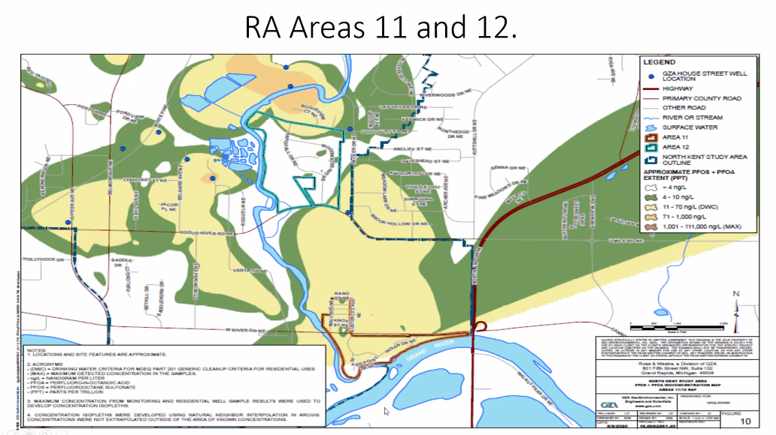

- Areas 11 and 12 are important to study and determine if these plumes are the source of contamination of the Plainfield Township wells which are located directly across the Grand River
- Rick Solle: we don’t know the source of the PFAS in the Plainfield Township water. There is the Beltline landfill, Boulder Creek former landfill, and House St plumes.
- The test wells are being installed as a phased in approach…if the initial well shows contamination, then another set of wells are stepped out and tested until the point of no contamination being found
- Testing will be done horizontally and vertically according the to Consent Decree
- Next steps:
  - EGLE will compile a Responsiveness Summary and send to the CAG (this will be a recap of comments received and what will be done with them)
  - CAG will receive data from the test wells to review and question/request more information if necessary
  - Determine whether these are separate plumes or if the space between is contaminated also and these are really just one large plume
  - Control the source of the plume to stop more PFAS from entering the groundwater
  - Creating accurate maps of all the plume flows
    - Analyze whether large amount of homes stopping the use of the groundwater due to being connected to municipal water will impact the direction (ie: cause higher concentration where there previously was not)
- Comments provided by CAG to EGLE:

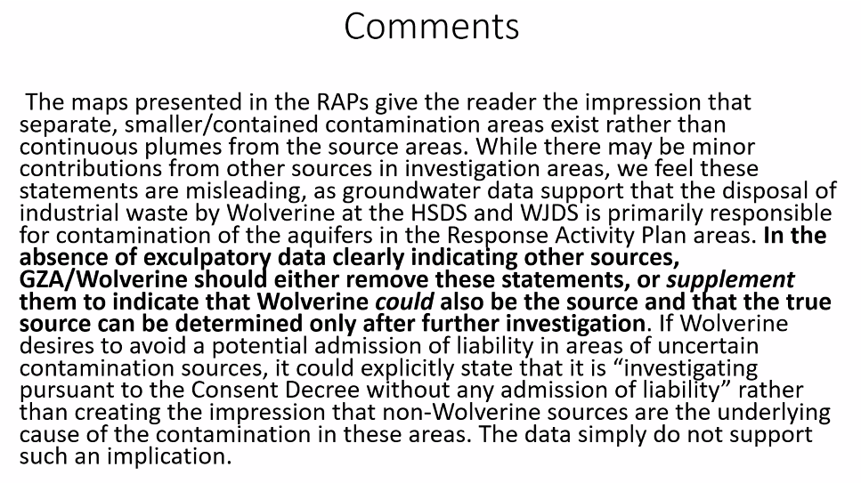
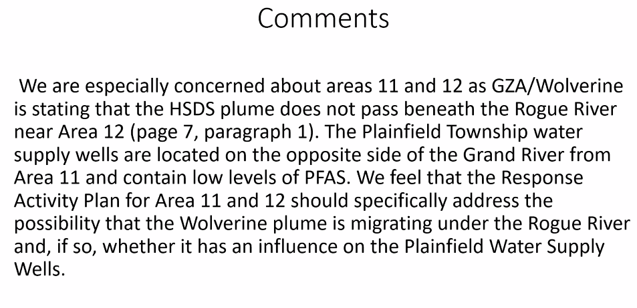

Discussion of Responses from EGLE to Public Comments
- Concern that the public is being asked to review and provide input on work plans, however, WWW only has to do what is in the Consent Decree. Is it worth our while to pour effort into requesting changes if they don’t legally have to happen?
  - Abby – brings our changes along with theirs to WWW & GZA for their approval. Public comment backs up EGLE’s requests.
  - Filter sampling, public sharing of information, map locations/drawings have all been due to input by the public

Update from MDHHS on Health Studies
Joost van t Erve, MDHHS
- MDHHS website has the results of the exposure assessment
- Recording of webinars are posted on the MDHHS website
- 360 people participated in the exposure assessment
- PFOA, PFOS, and PFHxS were higher than expected levels (higher than US population)
- Vary wide range of levels found – some people very high, some mid-level
  - This wide range is different for our area due to homes having a wide range of contamination levels. Most communities are exposed by the same source of contaminated water, so their intake was done at the same level
- Next report will be more in depth to make connections with length of time and level in water
  - Mid 2021
- Health component of the exposure assessment will be the upcoming Health Study
  - Working on processes, instruments, facility has been secured, staff are being hired
  - More people are eligible for the health study than the exposure assessment
  - Funding is being provided by
    - Late 2000: MIPES – funding from State of MI
    - Mid 2021: Belmont/Rockford Study – CDC grant (this study will be combined with others taking place across the US)

CAG Committee Reports:

Leadership
- Create a timeline/chart to show completed and upcoming actions and events
- Events to include work by: EGLE, EPA, Health Study, Municipal water hook ups

Communication
- Discussion of maintaining website and costs:
  - WMEAC has been hosting this site – this is not sustainable
  - We need help with content from the CAG
    - Jenny will create a schedule and template for CAG members to submit blog posts to be posted on the website and social media
  - Looking for ideas how to maintain and keep the site relevant
  - Gail will help digest environmental information for the website
  - Funding will be asked for by the CAG to the state
- Discussion of improved participation by community members
  - Using the timeline/chart – identify specific ways the CAG and community members can be involved
  - Get really specific about what we’re doing, how and why so everyone knows what’s happening and how they can participate
- Will use the Oct and Nov dates to review the calendar and upcoming activities, set priorities and actions

Membership
- Online membership invitation
  - Andrew Fishbeck uploaded the form to the CAG website

Technical
- None

Outstanding item:
- PFAS levels in fish – is the report going to be updated. MDHHS is still working on updating the guide. Joost will contact Laura Gossiaux – Laura presented this topic at a previous CAG meeting.

Upcoming Meeting Dates
- Thursday, October 15 – planning meeting
- Thursday, November 19 – planning meeting
- Thursday, December 17 – public meeting

