Wolverine Community Advisory Group  Full CAG Meeting  On Line  Monday, June 23,2025  4:00pm - 6:00 PM | 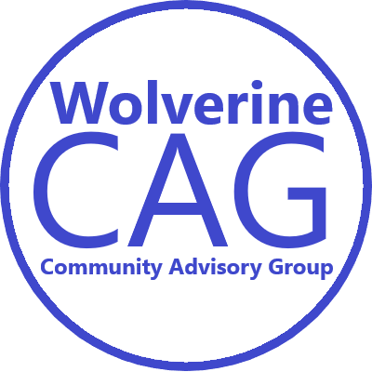
Join via Zoom:
https://us06web.zoom.us/j/85615336786
(Meeting ID: 856 1533 6786)

Phone-in Option:
(312) 626-6799
Code # 856 1533 6786

Draft Agenda (all times are approximate)

4:00 PM Welcome and Introductions

Project Updates

Guest Questions and Comments

CAG Communication Committee

Other CAG Business as Needed

6:00 PM Adjourn

The next Wolverine CAG Meeting will be on July 17, 2025

Wolverine CAG Mission:
1) ensure that the response activities at the Wolverine World Wide sites protect and sustainably restore
the environment for human health, fish, wildlife, and recreation, through community participation; and
2) that important community concerns are articulated, understood, and considered during any related
investigation and response action.

Wolverine CAG Ground Rules:
• work cooperatively with each other, supporting agencies, and other stakeholders,
• be respectful of all participants,
• approach all issues and viewpoints with an open mind,
• focus on what is important to the community as a whole and articulate community concerns in a way
that all stakeholders can understand,
• seek common ground wherever possible, and present and respect minority opinions where they exist

