Wolverine Community Advisory Group  Full CAG Meeting  Hybrid  Thursday July 17, 2025  6:00 PM – 8:00 PM | 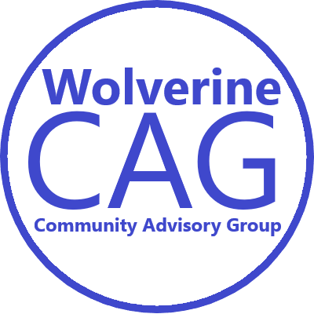
Join in Person:
Plainfield Township Charter Hall
6161 Belmont Ave NE, Belmont, MI 49306

Join via Zoom:
https://us06web.zoom.us/j/85615336786
(This link is good for all 2025 meetings, Meeting ID: 856 1533 6786)

Phone-in Option:
(312) 626-6799
Code # 856 1533 6786

Draft Agenda (all times are approximate)

6:00 PM Welcome and Introductions

      - EPA Updates
      - EGLE Project Updates
      - Fishing Advisory Signs
      - Hand Washing Stations Update
      - Guest Questions and Comments
      - CAG Communication Committee
      - Other CAG Business as Needed

8:00 PM Adjourn

The next Wolverine CAG Meeting will be on September 18, 2025 via zoom

Wolverine CAG Mission:
1) ensure that the response activities at the Wolverine World Wide sites protect and sustainably restore
the environment for human health, fish, wildlife, and recreation, through community participation; and
2) that important community concerns are articulated, understood, and considered during any related
investigation and response action.

Wolverine CAG Groundrules:
• work cooperatively with each other, supporting agencies, and other stakeholders,
• be respectful of all participants,
• approach all issues and viewpoints with an open mind,
• focus on what is important to the community as a whole and articulate community concerns in a way
that all stakeholders can understand,
• seek common ground wherever possible, and present and respect minority opinions where they exist

